Nag Bharadwaz Dasari

ID: 1259014

Email: [nag.dasari@snhu.edu](mailto:nag.dasari@snhu.edu)

IT 700: Capstone in Information Technology

Professor: Irving Burday

Date: 11/06/2017

SOUTHERN NEW HAMPSHIRE UNIVERSITY

Table of Contents

Project Design: 3

A. Problem Statement: 3

B. Stake Holder Analysis: 3

C. Overview of Design: 4

D. Database Design: 4

E. Process Flow: 7

F. Site Map: 8

G. Application Diagram: 9

H. Wireframe / Prototypes of the Application: 11

Project Implementation: 14

Test Plan and Results: 16

Summary of Work: 18

Recommendations and Future Enhancements: 19

Appendix 23

# Project Design:

## Problem Statement:

There is no proper website or service which would help patients from the United Nations of America know the cost across different nations which would offer the same surgery they would undergo. My project would compare the cost of Knee Surgeries between the USA and India. This is because typically Indian hospitals offer the same surgery and expertise at a much lower cost when compared to the United States.

The cost reduction is mainly because of the labor costs in India.

I came across this problem when one of my uncles visited United States with a pre-existing medical condition of the Knee. Over here his Knee problem became more acute. In order to get some relief doctors have suggested for a Knee replacement surgery. But, the cost incurred for a surgery in the United States was way higher than that of India. Even with insurance coverage in India the cost was comparable. If a patient’s insurance coverage did not provide more than 75% of the expense incurred, then it would be way cheaper in India. This is the business problem that I would like to solve.

## Stake Holder Analysis:

The project needs to be designed and implemented in such a way so that it caters to the needs and recommendations of the stake holders. The stake holders for our project are:

* Users
* Investors
* Company Management
* Developers
* Marketing Team
* Hospitals
* Advertisers
* Legal and Law team.

Keeping our stake holders in consideration we would build the website for our project. We would be using agile for our project and hence we would be in constant touch with our stake holders. Stake holders share their opinion and give us their suggestions on the development of the project. We can there by incorporate this feedback into our project to build a better application.

## Overview of Design:

The base case for the development cycle in SDLC would be the use of Design. Therefore our design needs to be strong and well structured. The design would itself comprise of various components.

## Database Design:

For our application we are using MongoDB to store our data. The various collections in our database are shown as follows:

Hospital Collection:

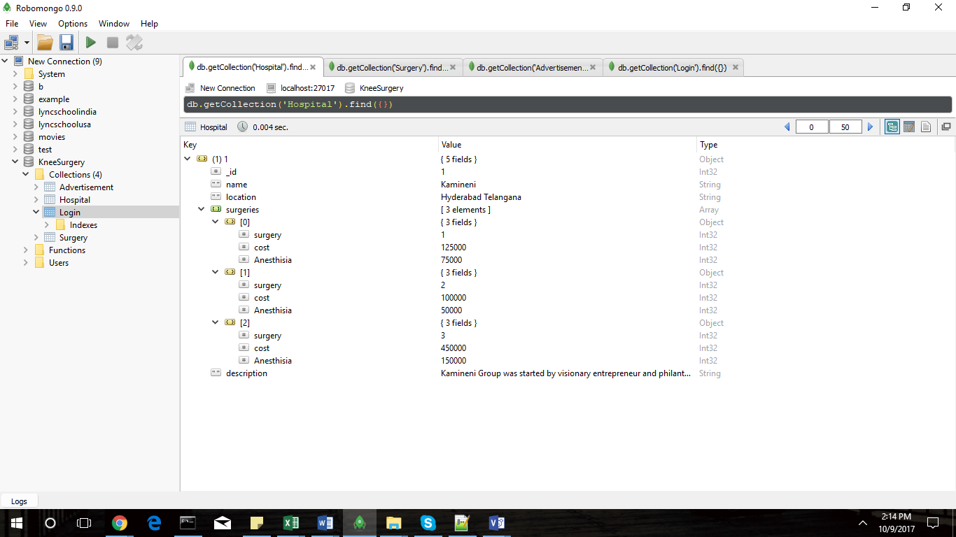

Surgery Collection:

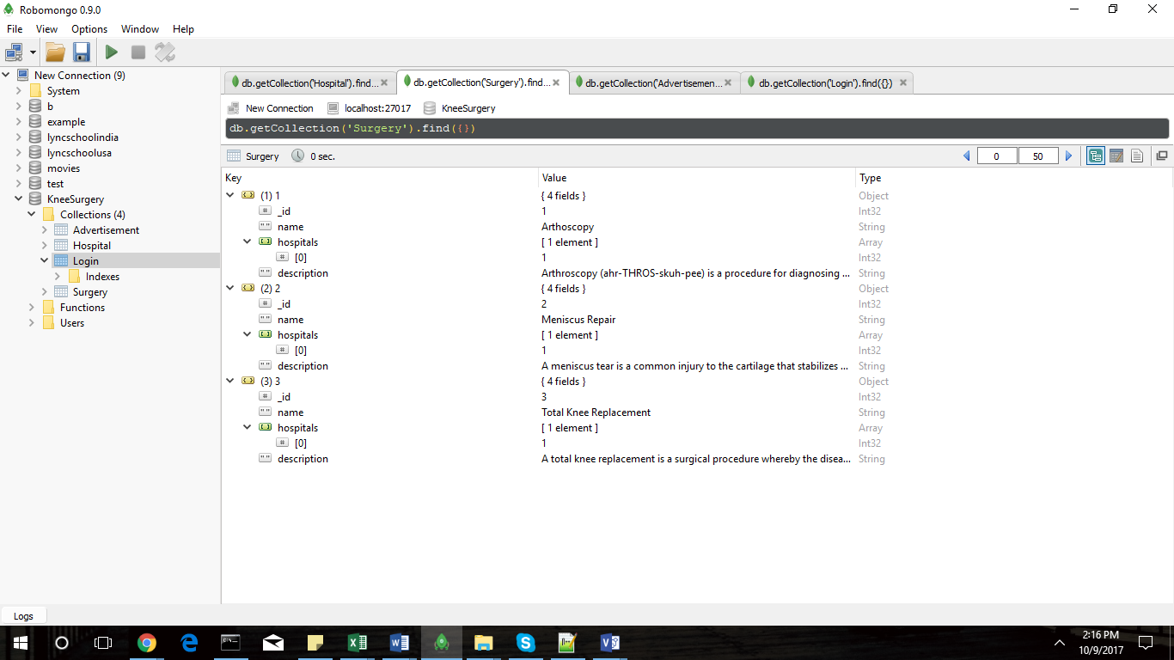

Advertisement Collection:

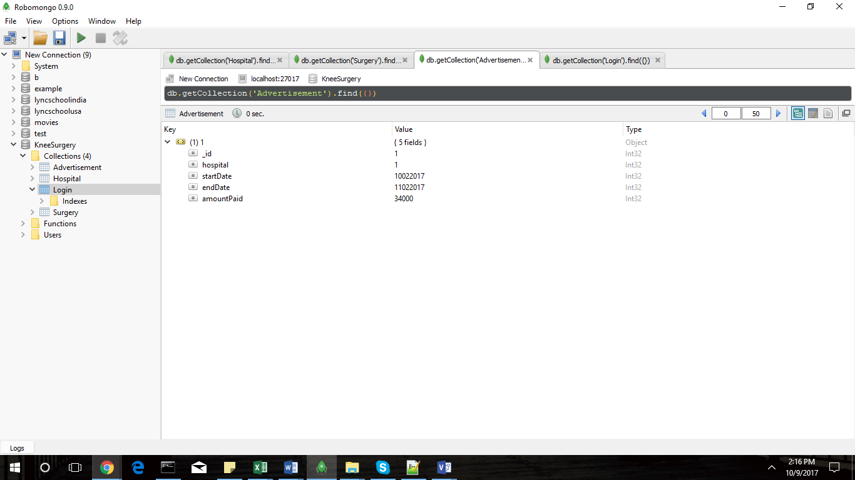

Login Collection:

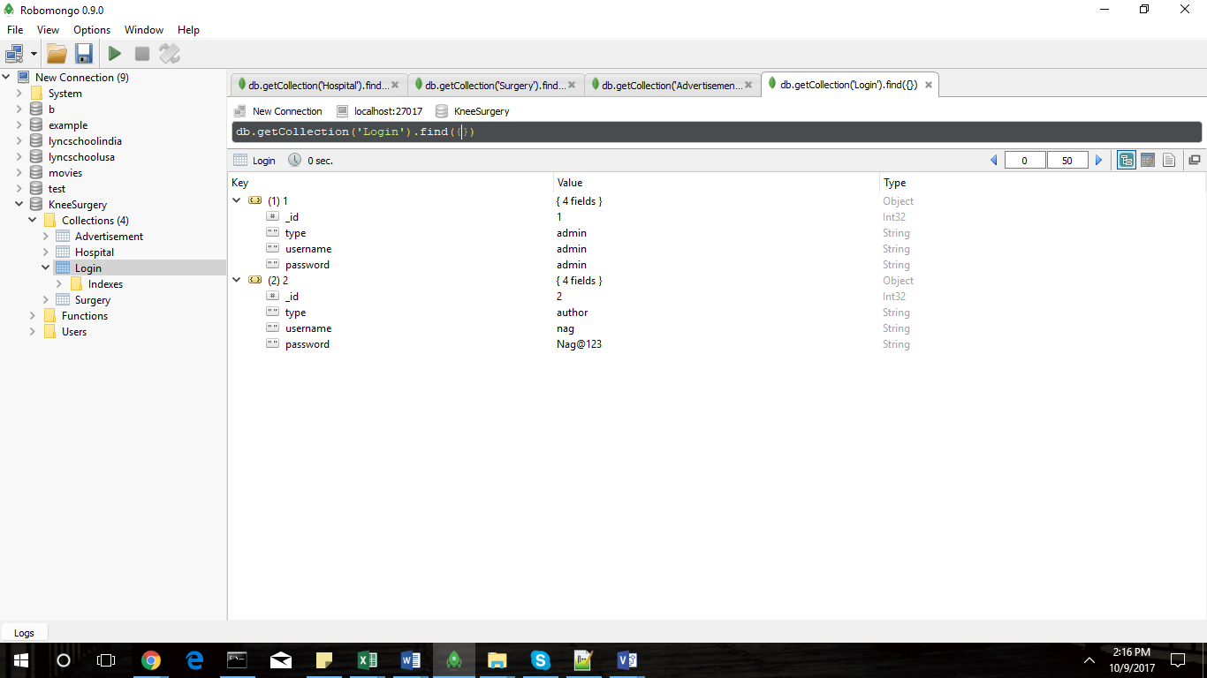

## Process Flow:

Process Flow is the visual representation of how the data flows between different modules of the project.

The project currently contains three important modules:

* User module: This is module which shows how the user interacts with website.
* Author Module: In this module we will be having authors who would put in hospital information as posts which was collected from different hospitals.
* Admin Module: This is controlling module over the authors and posts. Admins can add, edit and delete authors along with controlling the posts.

The process flow diagram of the same is shown below.



The above process flow diagram shows how the control flows for each process and how different users are able to interact with the different modules of the website.

## Site Map:

The site map shows where and how a user would be able to interact with the website. As we saw earlier there would be three points of entry into the website. The following site maps show how a user can interact which each of the interfaces.



The above site map shows how a normal user can interact with the website.

The next site map would show how an admin user and an author would interact with the website in order to create content or new authors along with how they manage advertisements.



## Application Diagram:

This diagram gives us a high-level overview of how the application would function in an overall sense.



## Wireframe / Prototypes of the Application:

The following are the screens with which a user can interact with the website.

Home Page:



Search Results Page:

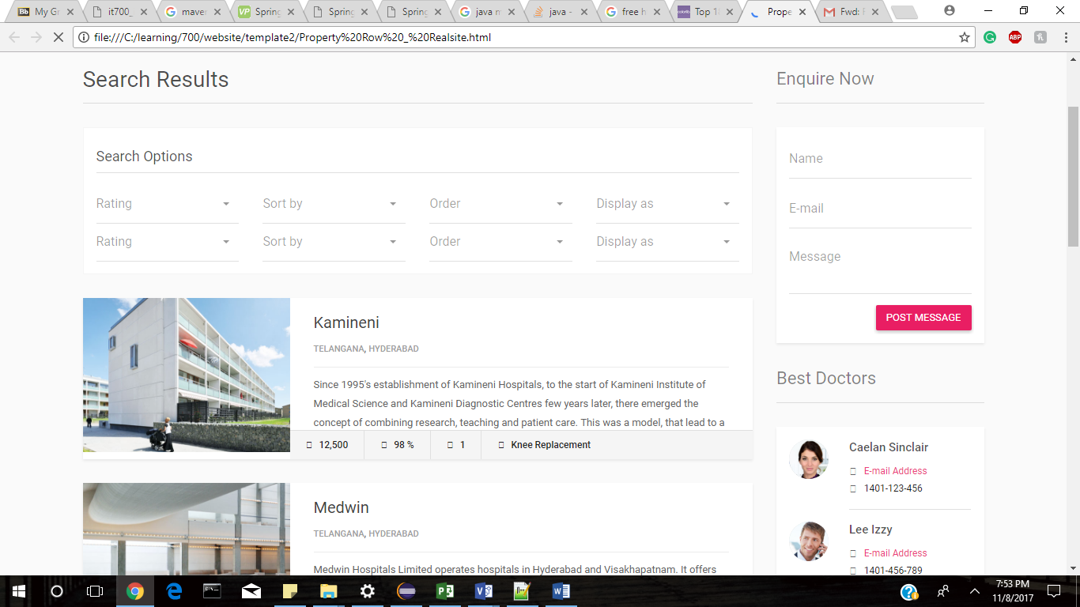

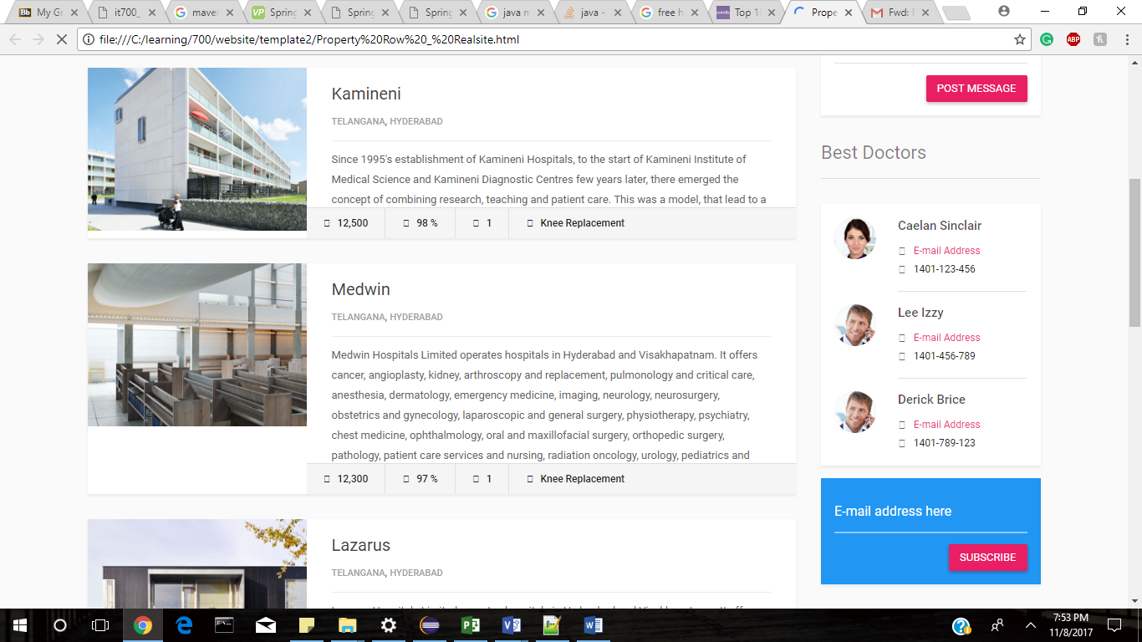



Hospital Page:



# Project Implementation:

Now that we have an idea of what needs to be done in the project we need to get a project plan built up so that we can have idea of how the project is being implemented. For this task we are using Microsoft Project to build our project plan.

The project plan for Safe Knee is given in the attached Project File Project Plan.mpp

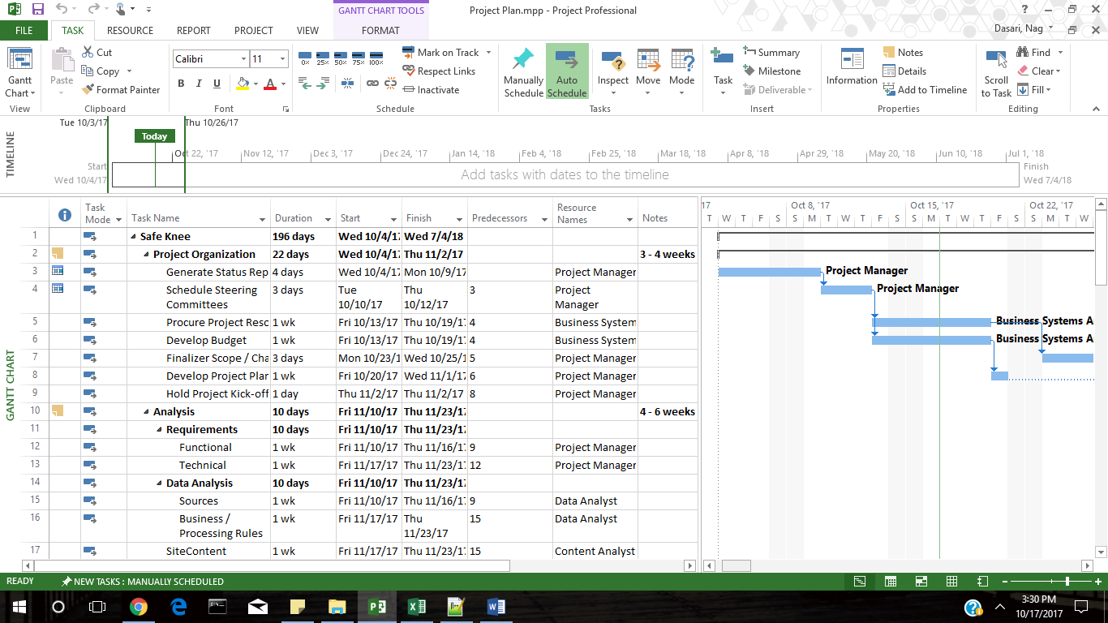

For the project to get started the first thing that has to be done is to Organize it.

That’s the reason why we first went through Project Organization for 22 days of the bat. Once this once done the project had to be properly analyzed about What were the requirements and the data analysis. The Analysis phase would last for 10 days. After this the Environment had to be setup. Since the website is being hosted on AWS it took a little time and was completed in 6 days.

After the Analysis then comes the design phase which would help setup a core plan of how the things would move ahead. Since, this was important we took a whole month to do this.

Once the Design was completed then the actual implementation or the development of the project would take place involving almost everyone. This is the biggest part and it stretches out for 78 days.

After the Development the project would thoroughly tested and many kinds of tests like User Acceptance, Integration and Systems test are run on it for over a period of 61 days.

After testing the project would be deployed for beta usage and would subject to a production test for a week.

Once all of these are done it would GO LIVE and be open for everyone to access it.

Any feedback which would acquire in the following weeks would be incorporated into the product.

# Test Plan and Results:

Once the project is completed we need to thoroughly check it for any bugs. There are various kinds of tests that are needed to be performed on the project in order to complete the testing phase.

The Test Plan with various phases and their corresponding results are given in an Attached Excel file called Test Plan.xlsx

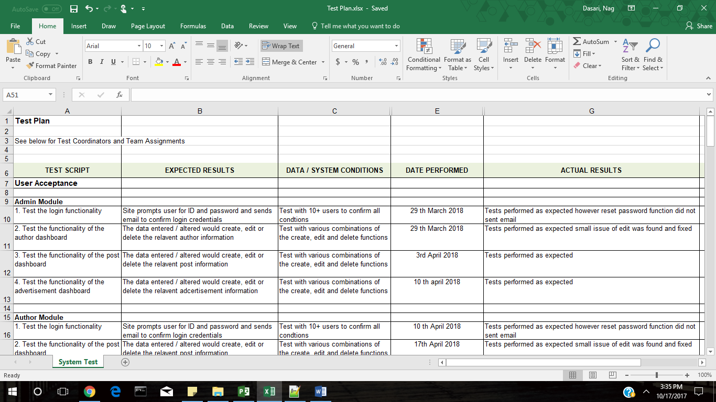

As noted previously testing is a very important phase in the SDLC as it points out any mistakes or bugs that might have creeped in the development of the project. Generally since the project extends for a such a long time there is a definite chance that bugs might creep in.

We would like to find them out ourselves before a user finds them out and hence it is recommended that we go through an extensive testing stage.

Our testing phase is for 61 days and covers a different kind of tests.

The first one is User Acceptance Test.

Here we test different interactive elements of the website. We test the three modules interactivity over here i.e.. Admin, Author and the User website modules. We found some changes that are to be done mentioned them in comments section.

Next up is the Integration test and though it might seem only like a few elements but they all need to be tested thoroughly and hence takes 15 days to complete this one too.

Then comes the biggest of the tests the Systems Test. This is particularly important as it tests how the system as a whole would function and stimulates conditions in which the system might fail. This is a big testing phase spans almost a month lasting for 31 days.

# Summary of Work:

The project was a long one stretching for about 240 days. The project went live on August 13th, 2018. Though the project went live there were few issues that we faced during this phase.

* The project was designed keeping in mind the patient interaction, but we forgot was to give detailed report about the visitors to a hospital from our website. This was due to fact that we ignored an important Stake holder in our Stake Holder analysis and would be fixed in our future revision.
* The design as then put in place and it was time for recruitment
* The other problem we found was to hire Java developers who had experience in working with MongoDB.
* Once the employees were recruited we completed the development.
* What we did not realize that the project took a lot of time into development making the investors uncomfortable.
* Our regular meetings with Stake holders and following the agile methodology helped secure us more time.
* After the development stage was completed with some delay we moved to the testing phase.
* During the testing [phase we found some issues especially with searches involving multiple parameters.
* After these issues were resolved we moved to deployment stage. We deployed the product successfully and the Project went live on August 13th, 2018.
* After this we received the feedback from hospitals asking for a dashboard for them. We are planning to release it for the next version of the project.

# Recommendations and Future Enhancements:

After completing our project and deploying it, we felt happy as well as got to learn a lot in the process of building it. Here is a summary of what we done, leant and need to do.

**Section 1: Success, Challenges and Lessons Learned**

|  |
| --- |
| **Successes:**  From our project these were the successful ones:   * Project Organization: A proper organization for the project was built upfront along with proper resource allocation which helped us face challenges. The project was organized in a way such that all the phases of the SDLC were properly given priority. This helped us taking care of attending every part of the project. * Testing: The testing phase went as planned, we learnt from the development stage of our project the coordination problems and we overcame them for the most part in the testing phase. * Deployment: Since we employed cloud based deployment for our project it was easier and faster for us to deploy. This deployment helped us in taking of the environment set up time to a great extent. Since, we went with AWS if there was a security breach we could ask AWS to help us out with that. |
| **Challenges:**   * Our first challenge was to acquire people who had the particular kind of skill set. To handle this, we had consultants come in and work for us. The skill set that we were looking for was Java developers who had experience with NoSQL experience and it became quite tough for us to hire resources. * The above reason coupled with communication gap between the teams from different countries has delayed the project and this made the Investors become little concerned about the project. The communication gap was mainly due to the fact that the teams were working in different time zones. * While building our project we were more focused on the patients/ user’s interface and we gave the hospitals/ authors just means to upload their data. The hospitals have expressed that it would have been great if they could see how much traffic/ revenue would they be getting from us to them. |
| **Lessons Learned:**   * Need to allocate enough slack time for the teams to communicate otherwise might cause miscommunication. After communication between the teams we need confirmation from both of them to see if they are on the same page which would need extra time. * Teams need assistance for coordination between them. I would like to add a project coordinator between the teams so as to assist them. * Need to consider each and every stake holder before we start building the project, as the change asked by the hospitals would require lot of efforts. This has brought in reporting as a new module into our project for the next phase. |

**Section 2: Modification Strategies and Actionable Steps**

With the experience that we got in the first version of the project we would like to have actionable steps going forward.

|  |
| --- |
| **Action Plan**:   * Hire in house resources for faster development process. * Adopt faster communication technologies so that minimal time is lost in communication between the teams. * Hire a Project Coordinator to coordinate between the teams. * Allocate more slack times for communication between teams. * From the next build version send copies of high level plans to inactive stake holders as they might have suggestions that we can implement before we go into designing and developing the project. |

**Section 3: Issues**

Here is a list of issues that have occurred during different stages of our project.

|  |  |  |  |
| --- | --- | --- | --- |
| **Issue Date** | **Issue Description** | **Status** | **Remedy / Resolution** |
| 1/25/18 | One of our Front-end developer had to take leave due to his personal issue | Closed | Hired a consultant temporarily to cover him. |
| 6/12/18 | Found an issue with Email notification system | Closed | Developers issued a patch code for the notification system. |
| 6/13/18 | Issue found with Editing fields in Admin and Author modules | Closed | Database Admin and the developers worked to resolve the issue. |
| 6/21/18 | We have found few of the links on our website did not link anywhere and hence could be considered as dead links. | Closed | Front End developer resolved it. |
| 7/10/18 | Problem with loading ETL scripts from hospitals as they have varying data in different entries. | Open | Database Admin is working with Content Analyst to have a simple interface in place |
| 7/14/18 | Skeptical about the disk size on AWS as it might not take the load when there is a sudden increase. | Closed | Upgraded the disk size 15 GB. |

# Appendix

List of issues found while testing:

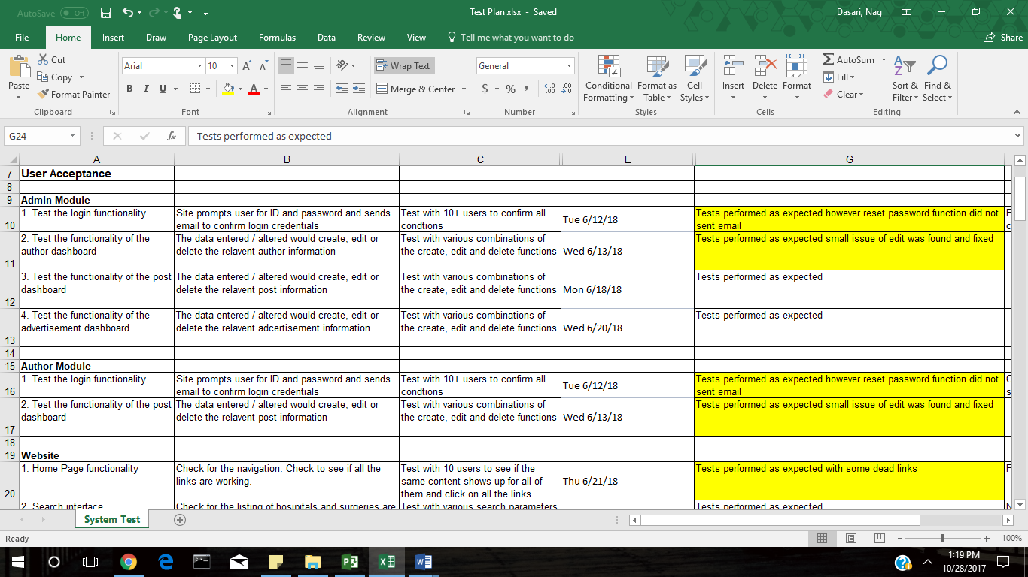

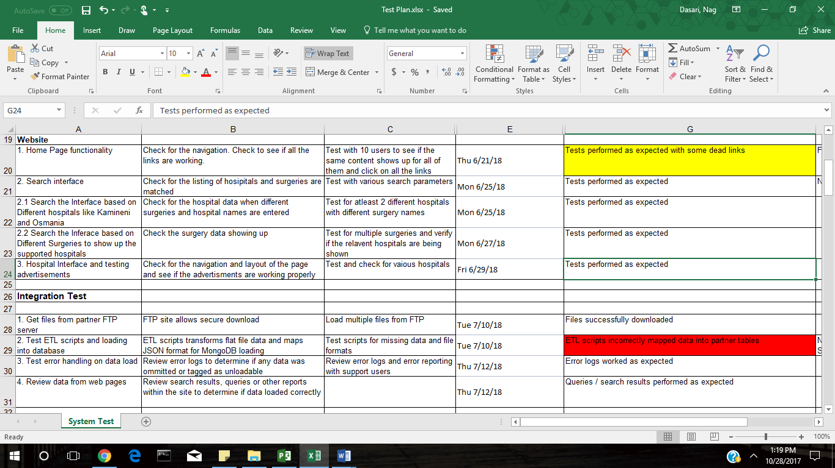

Resources Overview:

